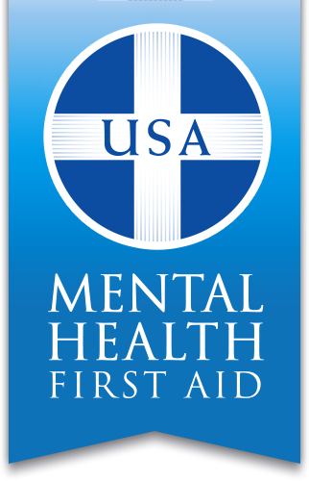
PUBLIC SAFETY
Mental Health First Aid Training
Open to: Fire and rescue, EMS, Police, Security Guards, Emergency Communications, OES, Inspections and code enforcement, DMV, and more.

Team Wellness Center presents: Mental Health First Aid Training.

Tuesday, September 26th 2017
9 AM – 5 PM
3646 Mt. Elliott, Detroit, MI 48207 (Team East)
Facilitators: Renardo and Shontori Bowles

Seating is limited, please RSVP to Alicia by phone or email at:
(313) 396-5300 ext. 244 or alicia.aloisi@t-mhs.com

Mental Health First Aid is a workplace mental health training program that teaches participants how to notice and support an individual who may be experiencing a mental health or substance use concern or crisis and connect them with the appropriate resources.

